The key moments of the job configuration (AC – 3,4):

* Jenkins server has been set up on local or remote machine with default port 8081 (AC - 1)
* Job should run on slave only (AC – 2, 5)

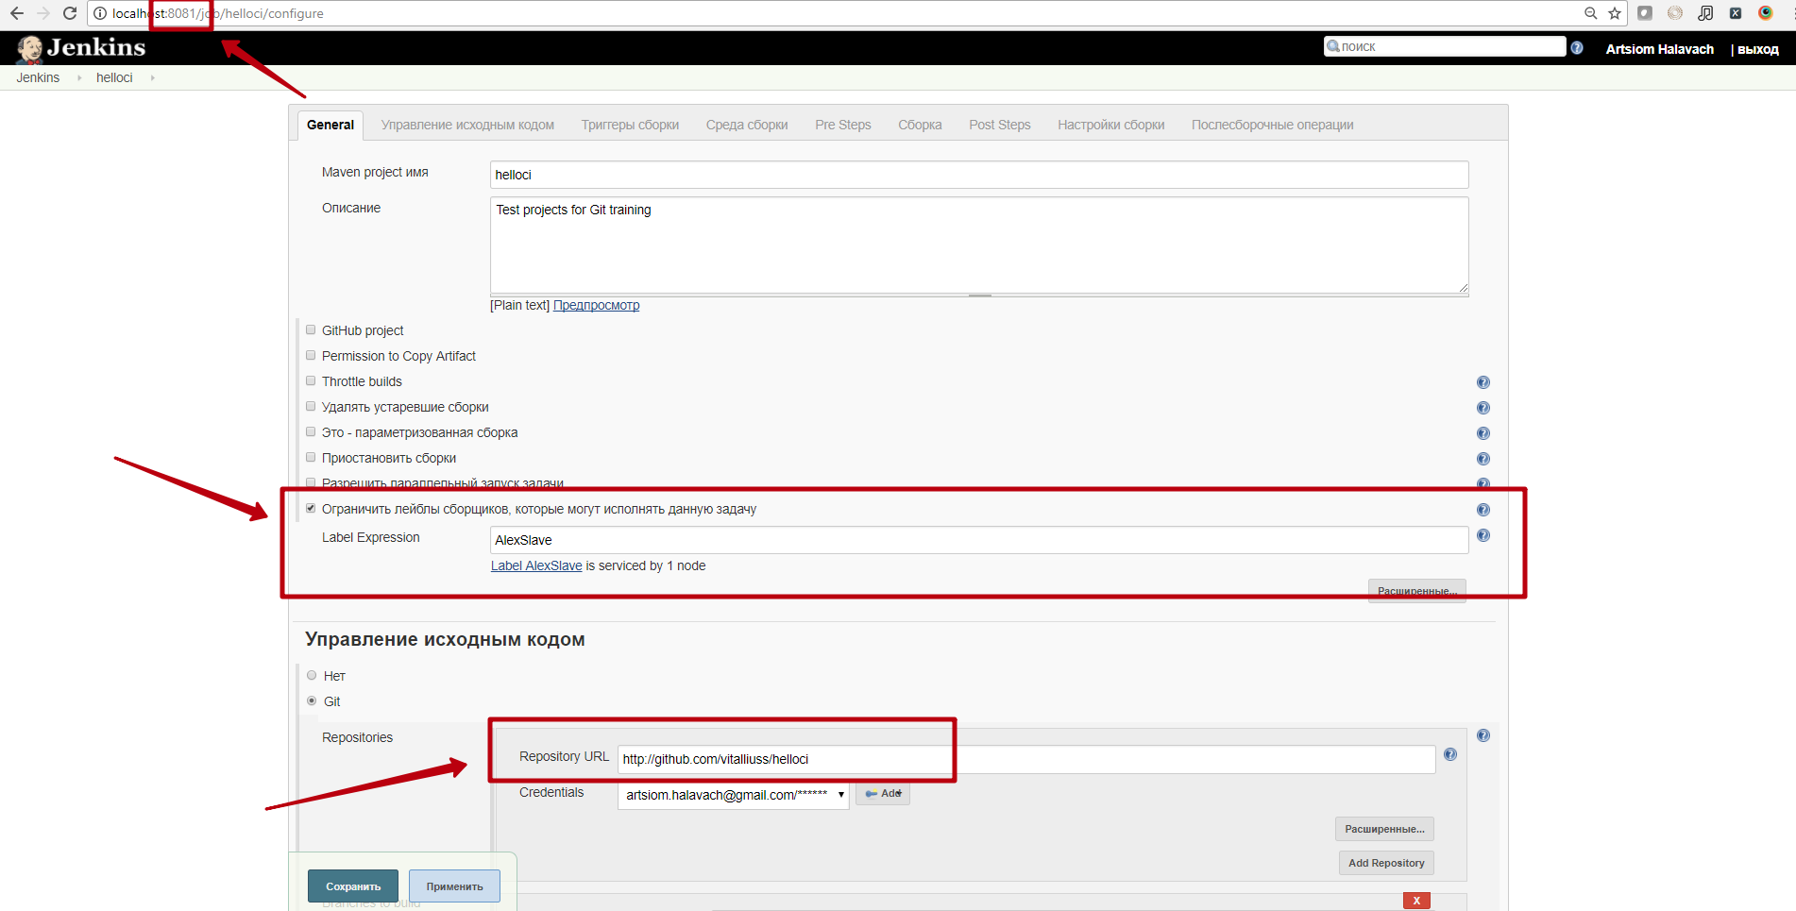

Slave was created (AC - 2):

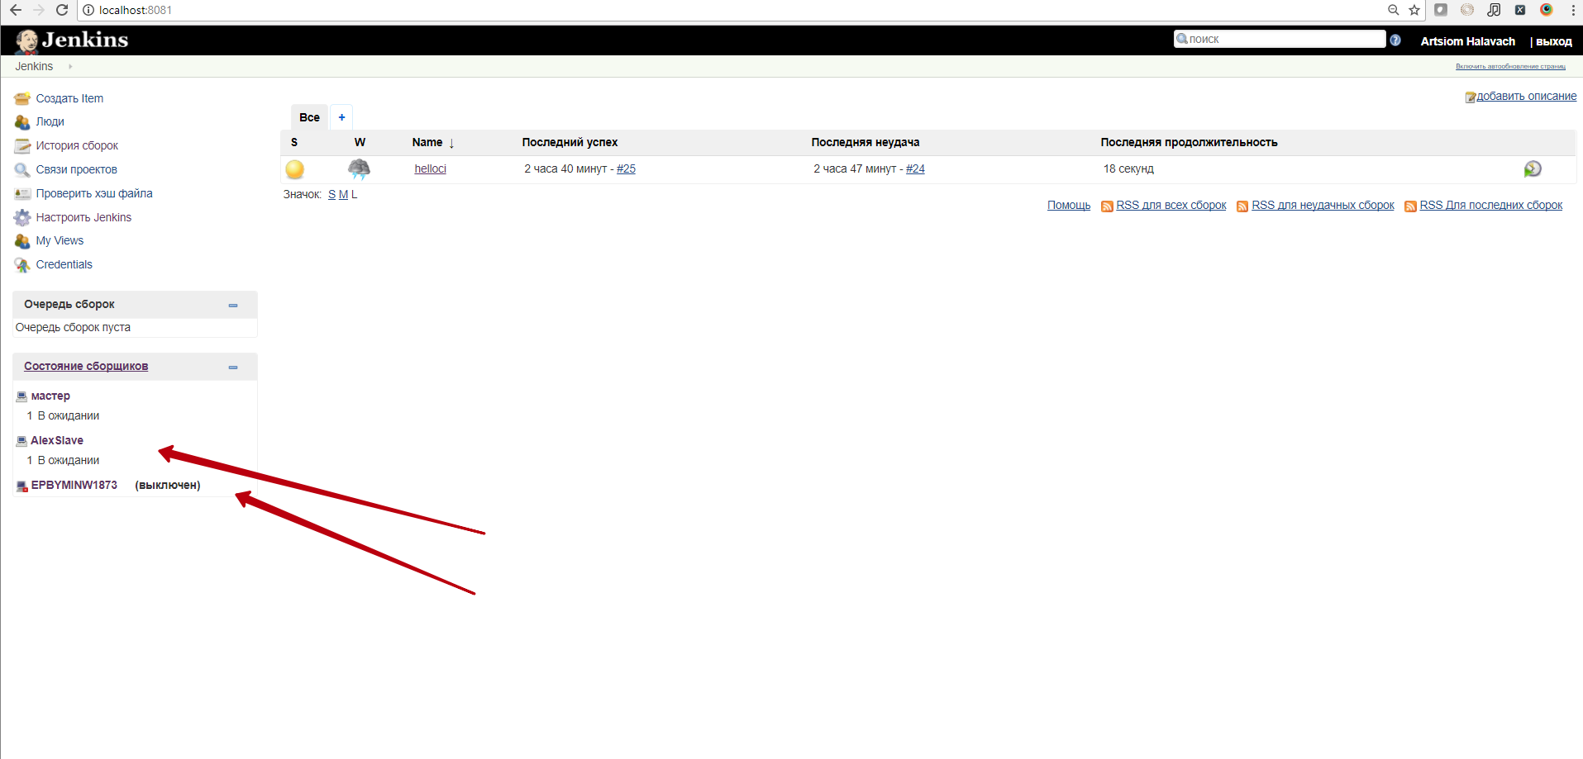

Triggering build configuration:

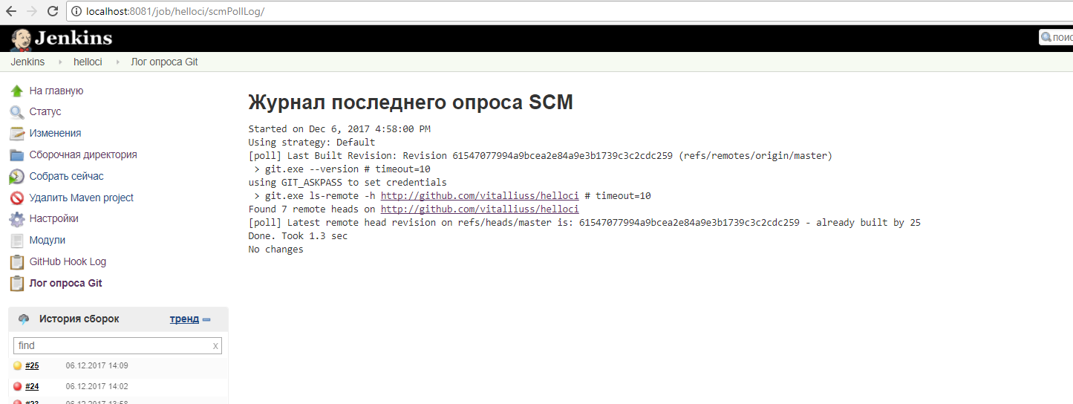

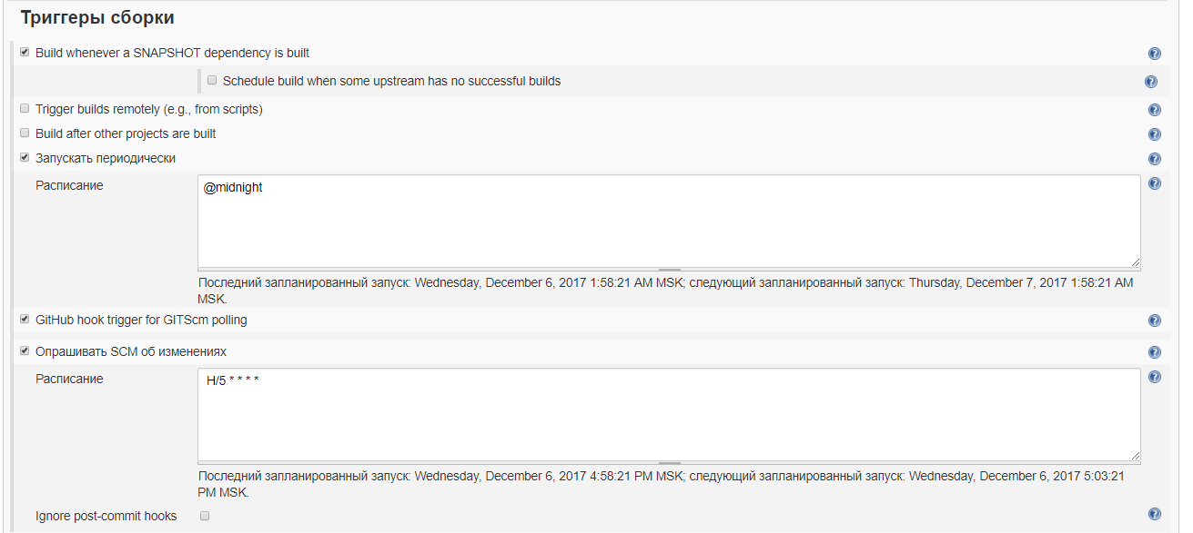

Job goal configuration:

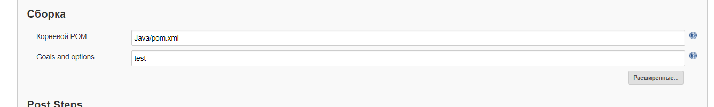

LOG:

Started by user [Artsiom Halavach](http://localhost:8081/user/Artsiom)

Building remotely on [AlexSlave](http://localhost:8081/computer/AlexSlave) (Slave2 WD) in workspace d:\Work\jenkins_test\workspace\helloci

Cloning the remote Git repository

Cloning repository <http://github.com/vitalliuss/helloci>

> c:\Program Files\Git\cmd\git.exe init d:\Work\jenkins_test\workspace\helloci # timeout=10

Fetching upstream changes from <http://github.com/vitalliuss/helloci>

> c:\Program Files\Git\cmd\git.exe --version # timeout=10

using GIT_ASKPASS to set credentials

> c:\Program Files\Git\cmd\git.exe fetch --tags --progress <http://github.com/vitalliuss/helloci> +refs/heads/*:refs/remotes/origin/*

> c:\Program Files\Git\cmd\git.exe config remote.origin.url <http://github.com/vitalliuss/helloci> # timeout=10

> c:\Program Files\Git\cmd\git.exe config --add remote.origin.fetch +refs/heads/*:refs/remotes/origin/* # timeout=10

> c:\Program Files\Git\cmd\git.exe config remote.origin.url <http://github.com/vitalliuss/helloci> # timeout=10

Fetching upstream changes from <http://github.com/vitalliuss/helloci>

using GIT_ASKPASS to set credentials

> c:\Program Files\Git\cmd\git.exe fetch --tags --progress <http://github.com/vitalliuss/helloci> +refs/heads/*:refs/remotes/origin/*

> c:\Program Files\Git\cmd\git.exe rev-parse "refs/remotes/origin/master^{commit}" # timeout=10

> c:\Program Files\Git\cmd\git.exe rev-parse "refs/remotes/origin/origin/master^{commit}" # timeout=10

Checking out Revision 61547077994a9bcea2e84a9e3b1739c3c2cdc259 (refs/remotes/origin/master)

> c:\Program Files\Git\cmd\git.exe config core.sparsecheckout # timeout=10

> c:\Program Files\Git\cmd\git.exe checkout -f 61547077994a9bcea2e84a9e3b1739c3c2cdc259

Commit message: "change project name in readme"

> c:\Program Files\Git\cmd\git.exe rev-list 61547077994a9bcea2e84a9e3b1739c3c2cdc259 # timeout=10

Parsing POMs

Established TCP socket on 61151

Copied maven33-agent.jar

Copied maven33-interceptor.jar

Copied maven3-interceptor-commons.jar

[Java] $ "c:\Program Files\Java\jdk1.8.0_121/bin/java" -cp d:\Work\jenkins_test\maven33-agent.jar;c:\maven-3.3.9\boot\plexus-classworlds-2.5.2.jar;c:\maven-3.3.9/conf/logging jenkins.maven3.agent.Maven33Main c:\maven-3.3.9\ "D:\Program Files\slave.jar" d:\Work\jenkins_test\maven33-interceptor.jar d:\Work\jenkins_test\maven3-interceptor-commons.jar 61151

<===[JENKINS REMOTING CAPACITY]===>channel started

Executing Maven: -B -f d:\Work\jenkins_test\workspace\helloci\Java\pom.xml test

[INFO] Scanning for projects...

[INFO]

[INFO] ------------------------------------------------------------------------

[INFO] Building hello-ci 1.0-SNAPSHOT

[INFO] ------------------------------------------------------------------------

[INFO]

[INFO] **--- maven-resources-plugin:2.6:resources (default-resources) @ hello-ci ---**

**[WARNING] Using platform encoding (Cp1252 actually) to copy filtered resources, i.e. build is platform dependent!**

[INFO] skip non existing resourceDirectory d:\Work\jenkins_test\workspace\helloci\Java\src\main\resources

[INFO]

[INFO] **--- maven-compiler-plugin:3.1:compile (default-compile) @ hello-ci ---**

[INFO] Changes detected - recompiling the module!

**[WARNING] File encoding has not been set, using platform encoding Cp1252, i.e. build is platform dependent!**

[INFO] Compiling 2 source files to d:\Work\jenkins_test\workspace\helloci\Java\target\classes

[INFO]

[INFO] **--- maven-resources-plugin:2.6:testResources (default-testResources) @ hello-ci ---**

**[WARNING] Using platform encoding (Cp1252 actually) to copy filtered resources, i.e. build is platform dependent!**

[INFO] skip non existing resourceDirectory d:\Work\jenkins_test\workspace\helloci\Java\src\test\resources

[INFO]

[INFO] **--- maven-compiler-plugin:3.1:testCompile (default-testCompile) @ hello-ci ---**

[INFO] Changes detected - recompiling the module!

**[WARNING] File encoding has not been set, using platform encoding Cp1252, i.e. build is platform dependent!**

[INFO] Compiling 1 source file to d:\Work\jenkins_test\workspace\helloci\Java\target\test-classes

[INFO]

[INFO] **--- maven-surefire-plugin:2.16:test (default-test) @ hello-ci ---**

[INFO] Surefire report directory: d:\Work\jenkins_test\workspace\helloci\Java\target\surefire-reports

[INFO] Using configured provider org.apache.maven.surefire.junit4.JUnit4Provider

-------------------------------------------------------

T E S T S

-------------------------------------------------------

Running com.github.vitalliuss.helloci.AppTest

Tests run: 5, Failures: 1, Errors: 0, Skipped: 1, Time elapsed: 0.027 sec <<< FAILURE! - in com.github.vitalliuss.helloci.AppTest

testShouldBeFailed(com.github.vitalliuss.helloci.AppTest) Time elapsed: 0.004 sec <<< FAILURE!

java.lang.AssertionError: null

at org.junit.Assert.fail(Assert.java:86)

at org.junit.Assert.assertTrue(Assert.java:41)

at org.junit.Assert.assertTrue(Assert.java:52)

at com.github.vitalliuss.helloci.AppTest.testShouldBeFailed(AppTest.java:21)

Results :

Failed tests:

AppTest.testShouldBeFailed:21 null

Tests run: 5, Failures: 1, Errors: 0, Skipped: 1

**[ERROR] There are test failures.**

Please refer to d:\Work\jenkins_test\workspace\helloci\Java\target\surefire-reports for the individual test results.

[JENKINS] Recording test results

[INFO] ------------------------------------------------------------------------

[INFO] BUILD SUCCESS

[INFO] ------------------------------------------------------------------------

[INFO] Total time: 4.209 s

[INFO] Finished at: 2017-12-06T14:09:43+03:00

[INFO] Final Memory: 22M/300M

[INFO] ------------------------------------------------------------------------

Waiting for Jenkins to finish collecting data

[JENKINS] Archiving d:\Work\jenkins_test\workspace\helloci\Java\pom.xml to com.github.vitalliuss.helloci/hello-ci/1.0-SNAPSHOT/hello-ci-1.0-SNAPSHOT.pom

channel stopped

Finished: UNSTABLE

# backUp

back up created

